Software Requirement Specification for Infra Audit

|  |  |
| --- | --- |
| **Name** | INDHUJA G J |
| **Roll no** | 7376221CS173 |
| **Seat no** | 52 |
| **Project ID** | 12 |
| **Problem Statement** | Infra Audit |

# Introduction

**Purpose:**

The purpose of this document is to present a detailed description of the Infra Audit. It will explain the purpose and features of the system, the interfaces of the system, what the system will do, the constraints under which it must operate and how the system will react to external stimuli.

**Technical Components**

|  |  |
| --- | --- |
| Front-end | ReactJs |
| Backend | Spring Boot |
| Database | MySQL |
| API | RESTful services |

**Problem Statement:**

* Lack of centralized platform for Infrastructure Audit team to manage audit locations, questions, and remarks efficiently.
* Absence of systematic tracking of auditor details, auditing status, and observations, leading to potential data discrepancies.
* Inefficiencies in the allocation of auditing tasks, hindering timely completion and follow-up.
* Risk of overlooking critical audit tasks or locations due to manual coordination and oversight challenges.
* Need for a streamlined, user-friendly solution to enhance the overall audit process effectiveness and compliance.

**Scope of Project:**

* + - This software system will serve as a portal for the Infra Audit team enabling them to view the allotted auditing location, the questions corresponding to the location and the remarks. From the administrator perspective, the system will provide **Auditor details, Auditing status and its observation.**
    - Administrators can view the auditing and the auditor details and also can allot auditing to the required person. Once allotted, the particular person will be notified with an email. Then, they can login into the portal and see the further details about their location.

**PROJECT-FLOW:**

**Purpose:**

To create a centralized platform for managing Infrastructure Audits, facilitating efficient coordination and communication among audit teams and administrators, thereby enhancing the effectiveness of the auditing process.

**Scope:**

This system encompasses user authentication, audit allocation, location-specific questions, audit status tracking, and email notifications. It integrates with existing email systems to ensure seamless communication and task management.

**Business Context:**

The Infrastructure Audit system aims to streamline auditing procedures, reduce vulnerabilities, and ensure compliance with standards. Primary stakeholders include audit teams, administrators, and relevant department heads.

**Consideration:**

- All users have designated accounts for authentication.

- Users have regular access to internet-enabled devices.

**Dependencies:**

- Integration with authentication services for user validation.

- Reliable performance and availability of email servers for notifications.

**User Personas:**

- Auditor: Needs access to assigned audits and relevant details to conduct assessments effectively.

- Administrator: Manages audit allocations, tracks audit progress, and resolves any issues.

- Department Head: Receives audit reports and ensures corrective actions are implemented.

**User Stories:**

- As an auditor, I want to access assigned audits and related information easily to perform assessments efficiently.

- As an administrator, I need to allocate audits to appropriate personnel and track their progress to ensure timely completion.

- As a department head, I want to receive audit reports promptly and oversee the implementation of corrective measures to enhance infrastructure security and compliance.

# Functional Requirements:

**User Authentication:**

- Secure login utilizing Google OAuth for all system users.

**Audit Allocation:**

- Administrators can assign audits to specific auditors within the system.

- Auditors receive email notifications upon assignment.

**Audit Details Management:**

- Auditors can access location-specific questions and remarks associated with their assigned audits.

- Administrators can modify audit details as needed, including updating questions or remarks.

**Audit Status Tracking:**

**-** Auditors can update the status of audits (e.g., pending, completed) within the system.

- Administrators can view the status of all audits, including their progress and any outstanding tasks.

**Email Notifications:**

- Automated email notifications are sent to administrators and auditors for important updates, such as audit assignment.

**Conflict Resolution:**

- System automatically detects scheduling conflicts between audit assignments and provides options for resolution.

- Administrators can resolve conflicts by reassigning audits, adjusting schedules, or prioritizing tasks.

**Dynamic Dashboard:**

- Real-time dashboard displaying the current status of all audits, including pending, ongoing, and completed audits.

- Auditors and administrators can interact with the dashboard to view detailed audit information and perform actions such as updating audit status or resolving conflicts.

**ADMIN’S INTERFACE**

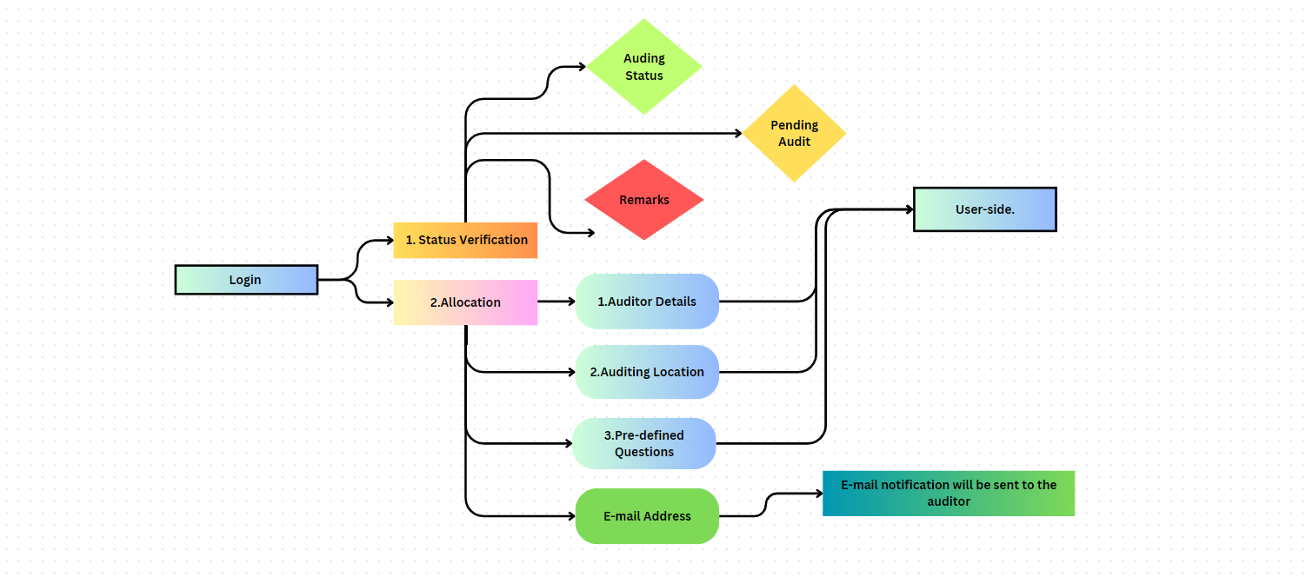

**USER’S INTERFACE**

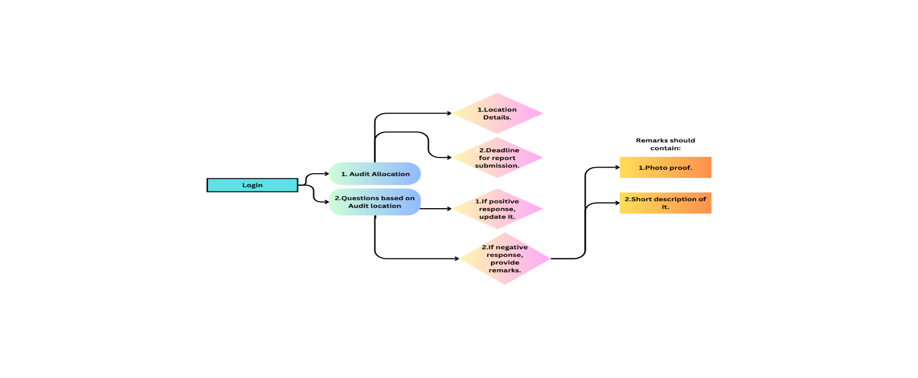

**ER DIAGRAM**

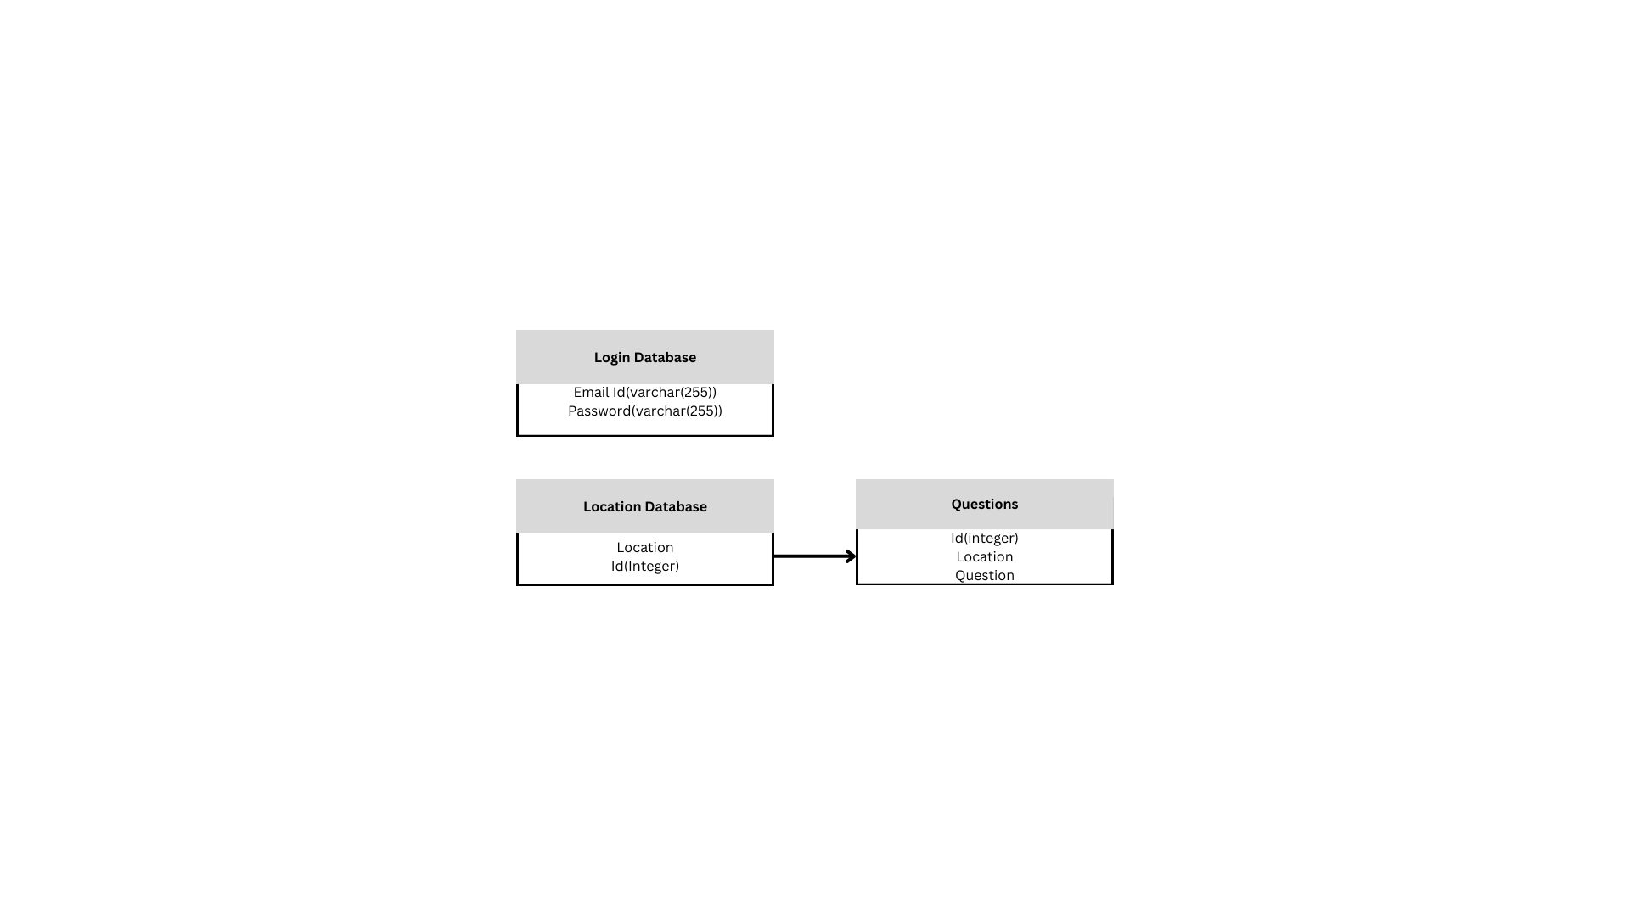

**Prototype of the Project**

**Login Form:**

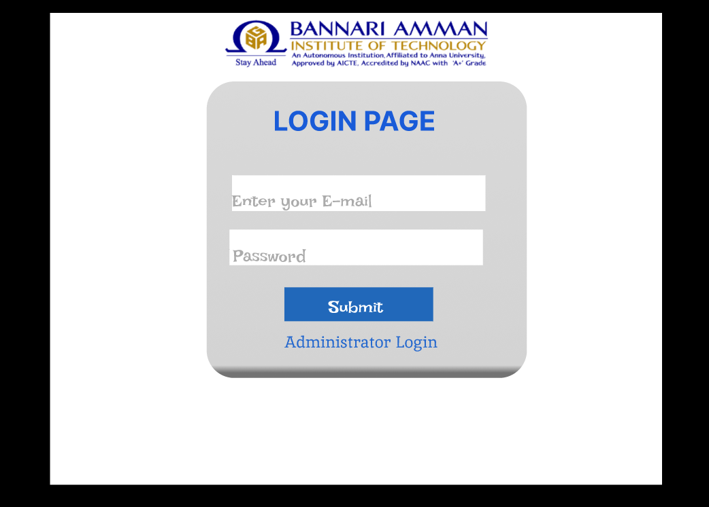

**Audit Form:**

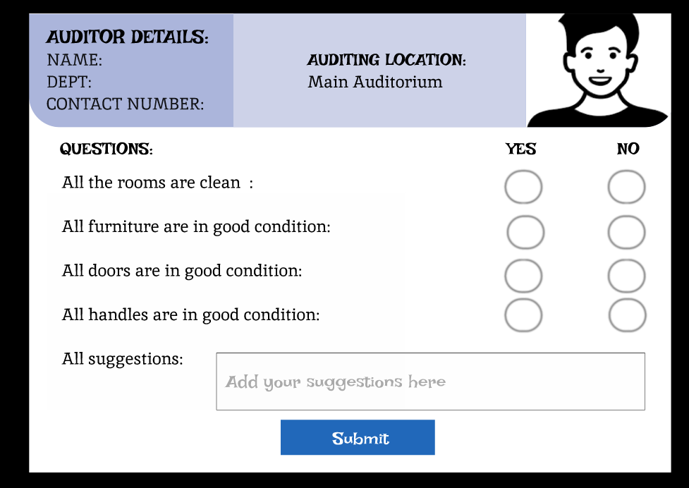

**If no selected, these questions will be asked:**

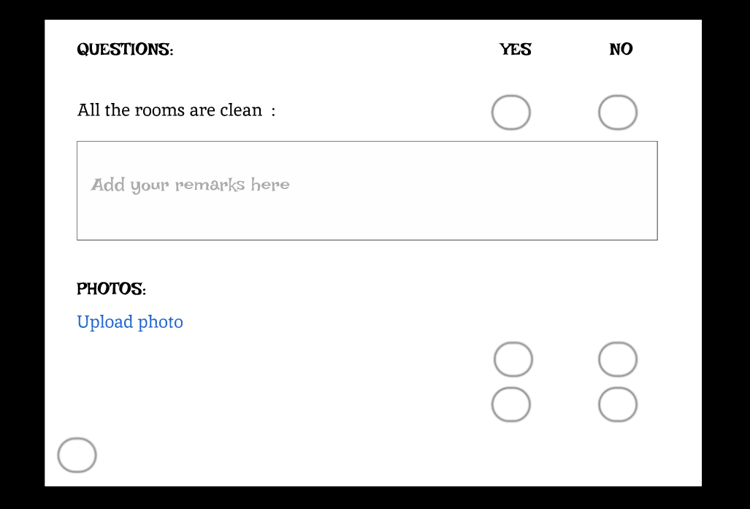

**Administrator’s View:**

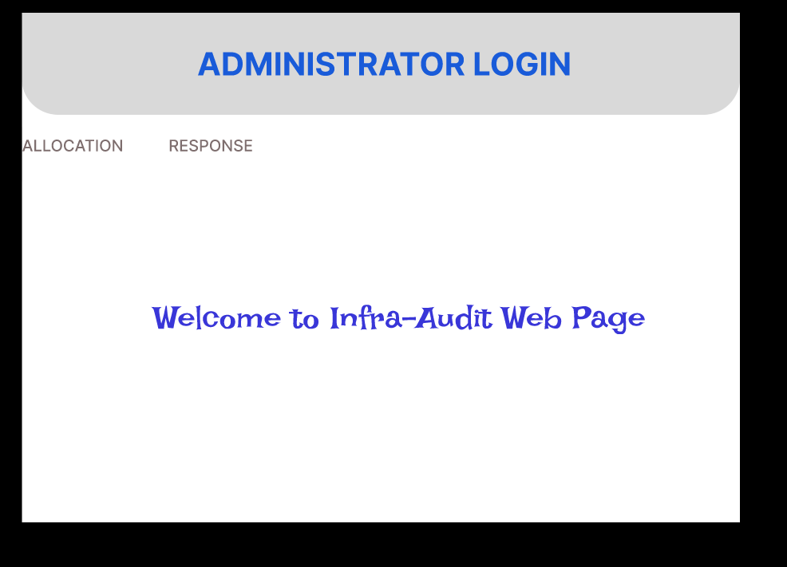

**Form for allocating Auditing person:**

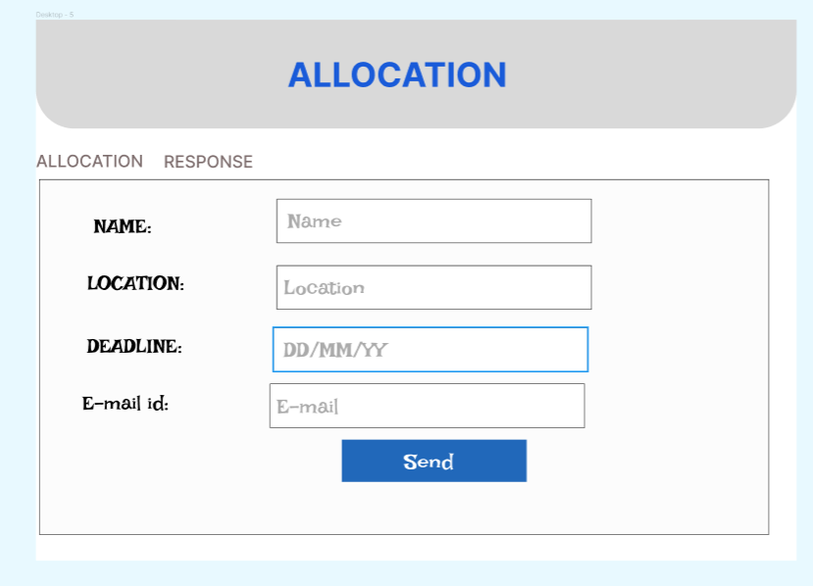

**Responses page:**

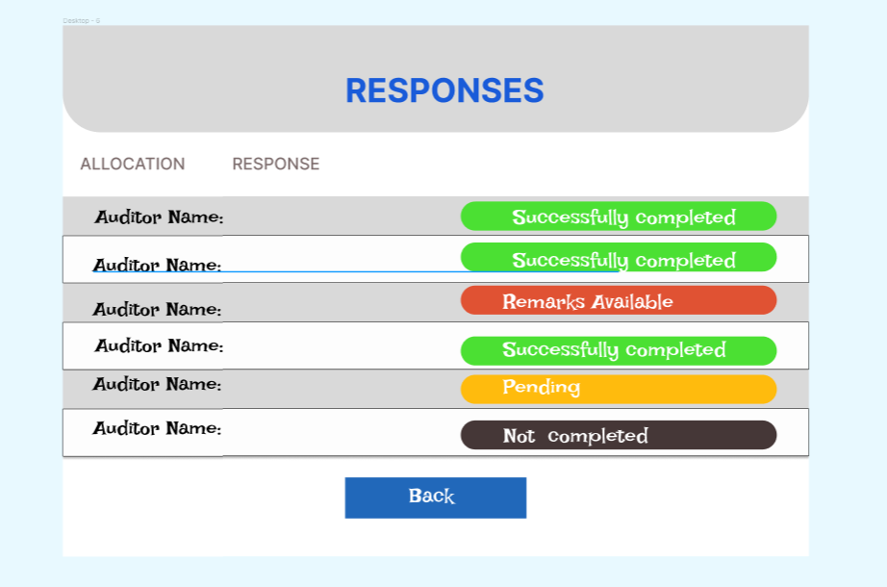

**Remarks Available section:**

